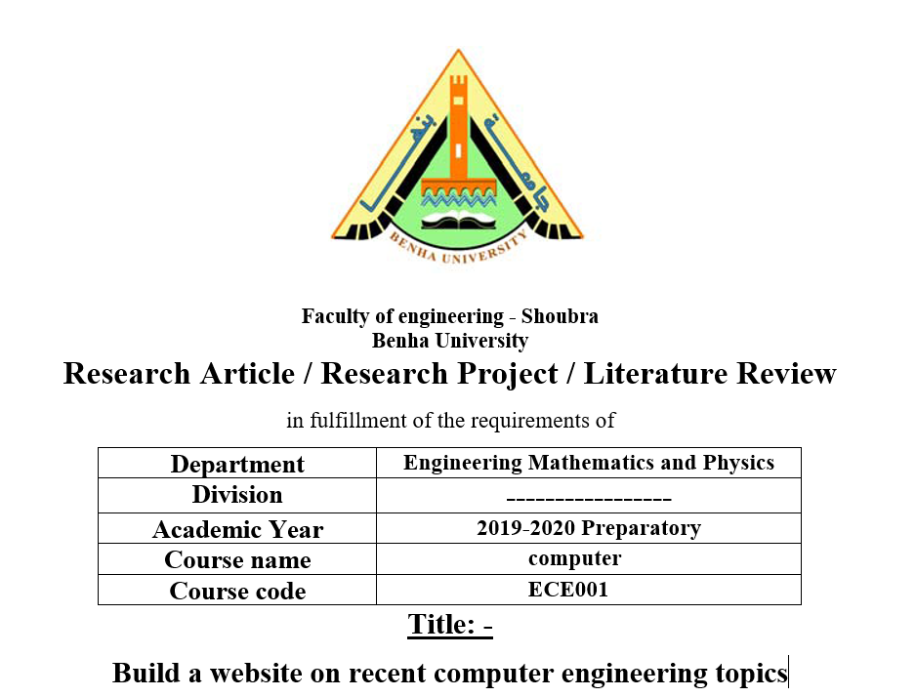

**by**

|  |  |  |  |
| --- | --- | --- | --- |
| **Name** | **Edu mail** | **B.N** | **Tobic** |
| **أحمد عقل أبوالعز** | **ahmed195101@feng.bu.edu.eg** | **98** | **Artificial Intelligence** |

**Examiners committee**

|  |  |
| --- | --- |
| **1** | **Dr.Ahmed Bayoumi** |
| **2** | **Dr.Shady Elmashad** |
| **3** | **Dr. Abdelhamid Attaby** |

**Github link :** [**https://github.com/ahmedakl045/ECE001-ahmedakl.githup.io**](https://github.com/ahmedakl045/ECE001-ahmedakl.githup.io)

**Github page :** [**https://ahmedakl045.github.io/ECE001-ahmedakl.githup.io/**](https://ahmedakl045.github.io/ECE001-ahmedakl.githup.io/)

# **Application brief :**

# 

**Artificial Intelligence is one of the new developments of systems that aim to mimic human reasoning. Scientists have made huge strides in weak AI systems, while in strong AI systems they have made just a modest mark. Some of us have at some point in our lives used Siri, Google Assistant, Cortana or even Bixby. What is it? They are our personal Digital Assistants. They help us find useful information when we ask with our voice; we can say 'Hey Siri, show me the nearest fast food restaurant' or 'Who is the twenty-first US President? 'And the assistant will respond with the correct Data through either your phone or a web search. This is simple Artificial Intelligence proof! Let's read some more! Artificial Intelligence is the ability to understand and analyze on a computer program.**

**In the year 1950 John McCarthy coined the word Artificial Intelligence. He said, ‘Every aspect of learning or any other feature of intelligence can in principle be so precisely described that a machine can be made to simulate it. An attempt will be made to find how to make machines use language, form abstractions, and concepts, solve kinds of problems now reserved for humans, and improve themselves.**

**Screenshots :**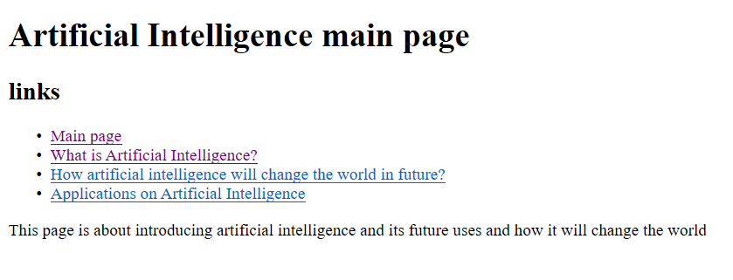

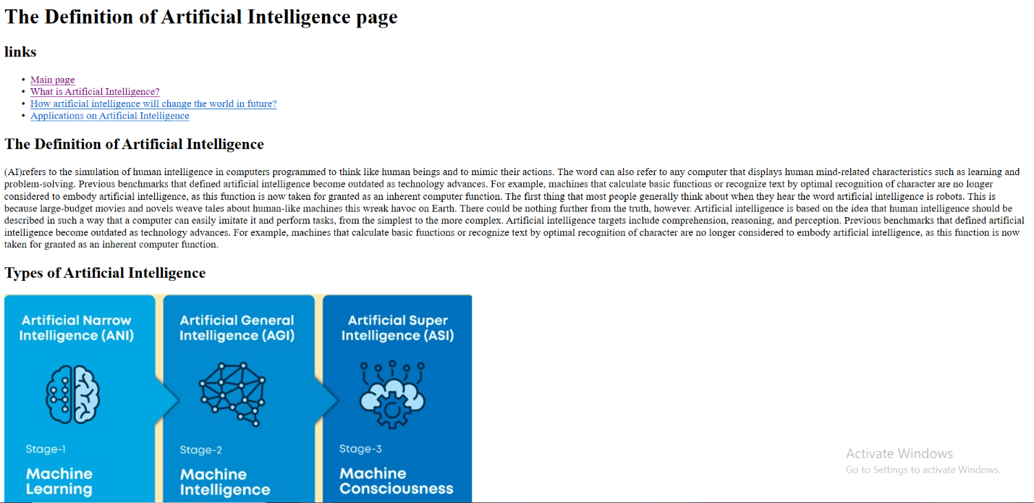

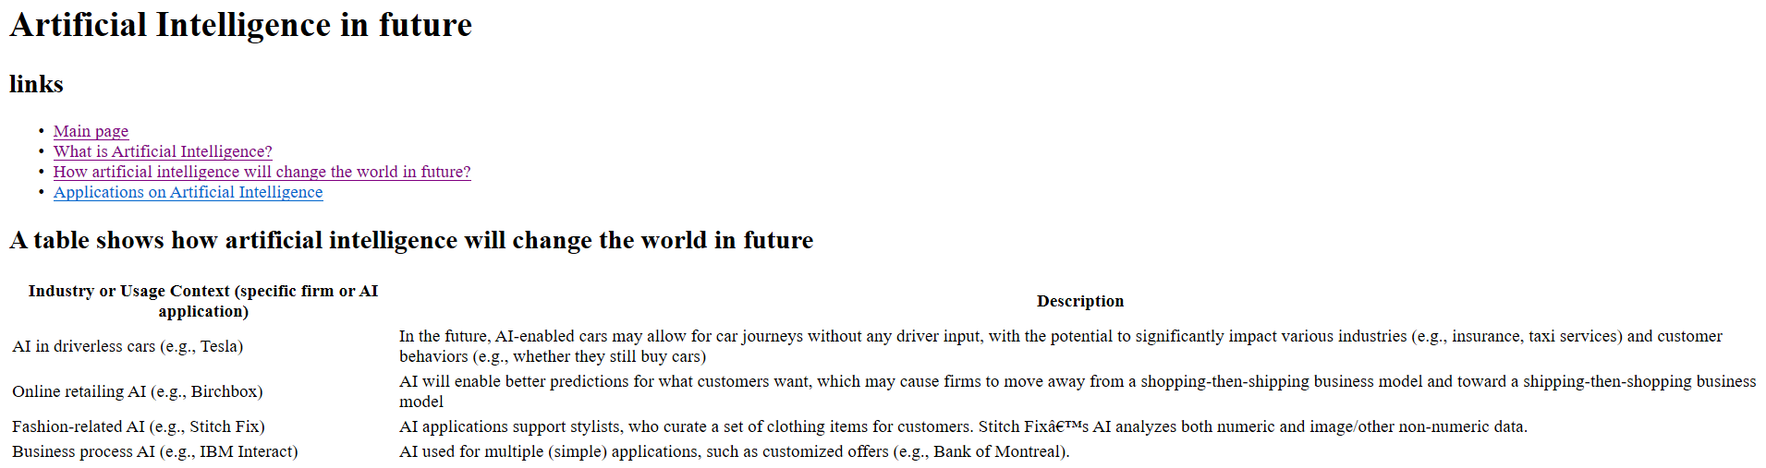

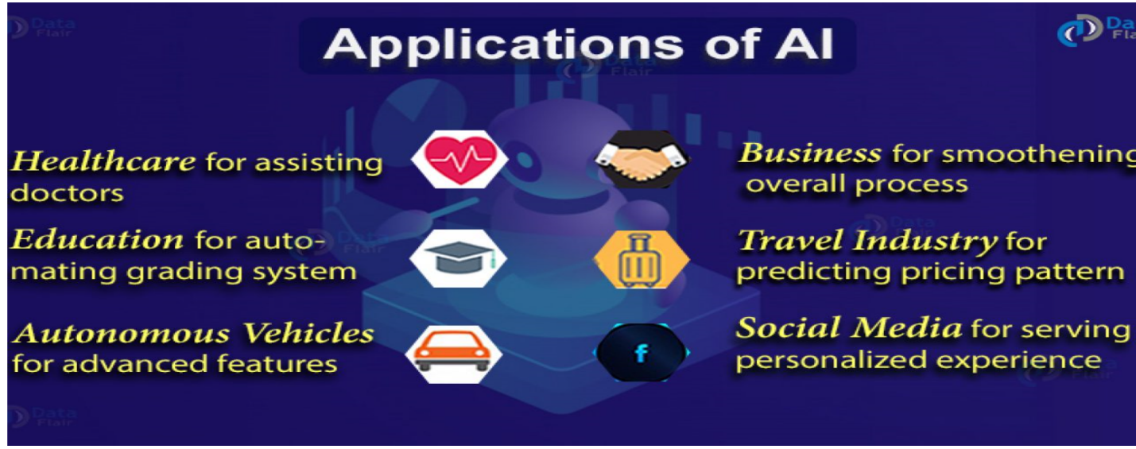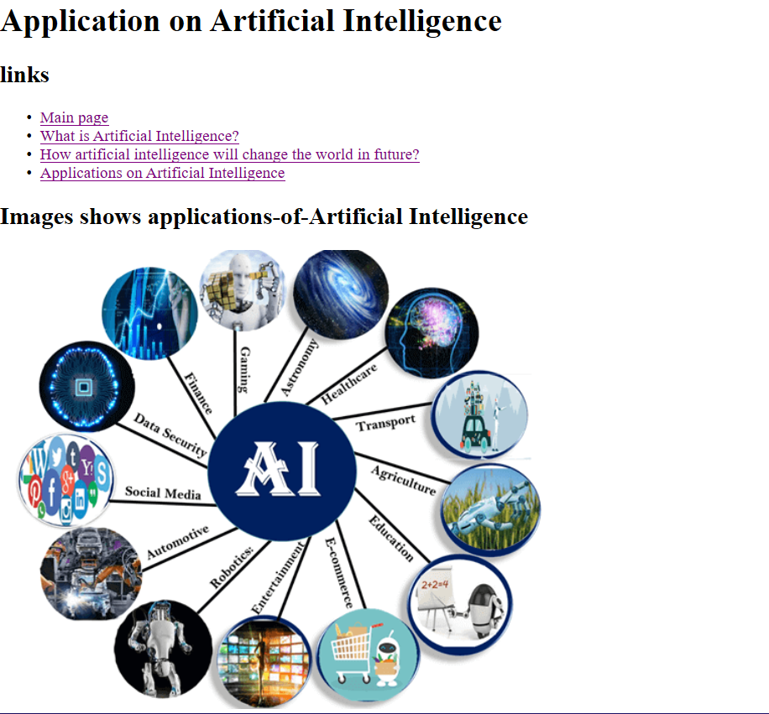

**Source code:**